Release Note

Production BOM Workflow Approval

# 1 Basic Details

|  |  |
| --- | --- |
| Customer |  |
| Customer Name | N/A |
| Customer PM  (Where appropriate) | N/A |

|  |  |
| --- | --- |
| Release Control |  |
| Reference No. | BOM WF |
| Author | Marcus Ambra |
| Release | 2004-01R |
| Risk Level | High |
| Release Date | 12/04/2020 |
| Release Media | FOB |
| Release Reason | Incident |
| Database Version | Dynamics NAV 2018 11.0.35815 |
| Package Name | NA |
| Delivery Method | NA |
| Customer Approval  (Delivery) | NA |

|  |  |
| --- | --- |
| Work Detail |  |
| Project Name | Prod. BOM Workflow Approval |
| Project Manager | NA |
| Project Phase | Project |
| Person (Developer/Consultant) | Marcus Ambra |
| Functional Area | Production BOM |
| Reviewer/Approver (Peer/Senior) |  |
| Design Reference | NA |
| Development Release note no. | NA |

# 2 Overview

## Risk Level

This release has a High risk level for the following reasons:

.

## Business Requirements

### Issues Addressed

#### 2.2.1.1 Issues Resolved from Previous Build

The following issues have been marked as development completed and are ready for testing.

|  |  |  |
| --- | --- | --- |
| Issue | Summary | Reported by |
| NA | NA |  |

#### Known Outstanding Issues

|  |  |  |
| --- | --- | --- |
| Issue | Summary | Reported by |
|  | NA |  |

## Assumptions

Please note if the lines have the same GL Account and the same description then the lines will be compressed in one and the first line description will be displayed in the General Ledger Entries.

# 3 Technical Details

## 3.1 Summary of Solution Modifications

1. **Table: 99000771 – Production BOM Header**

* Created new field 50000 – Options: Open, Pending Approval, Released

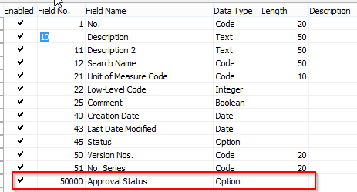

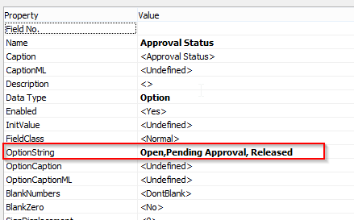

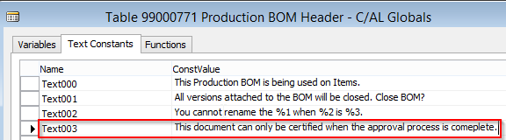

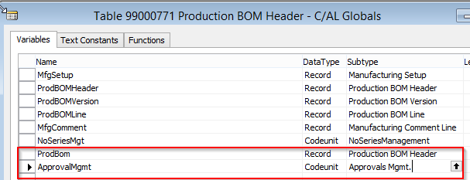

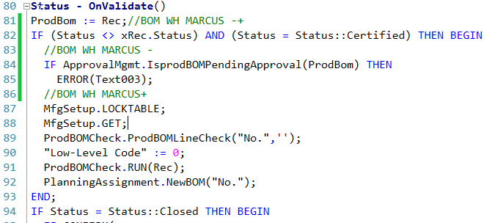

1. **Page 99000786 – Production BOM**

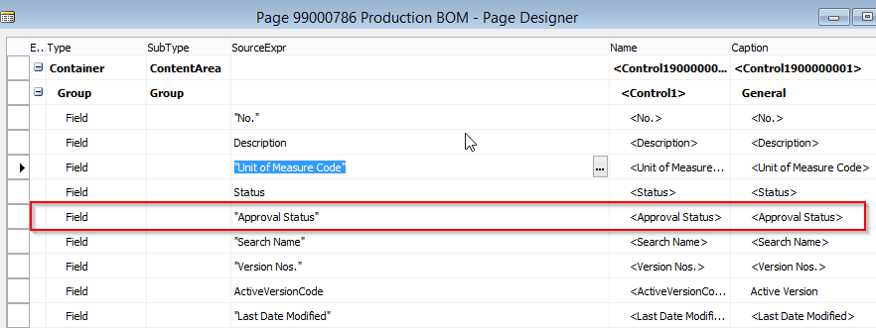

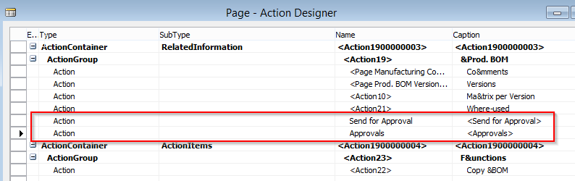

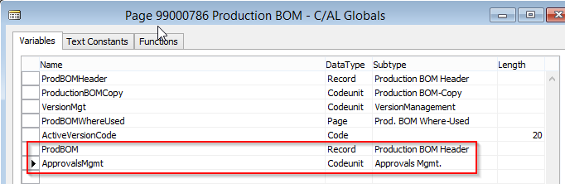

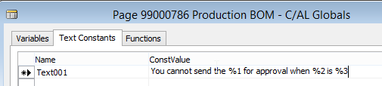

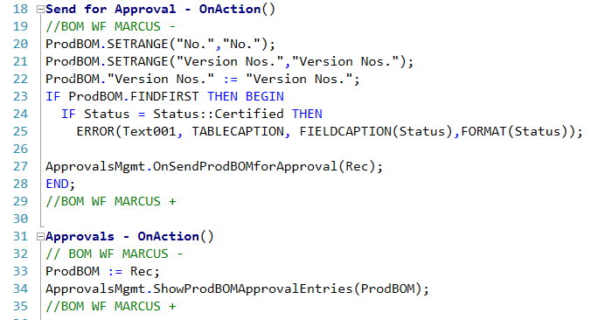

1. **Codeunit 1510: 49 – Notification Management**

**GetDocumentTypeAndNumber**

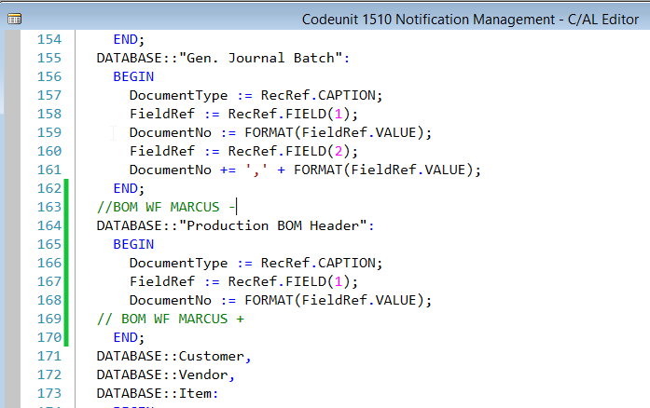

1. **Codeunit 1520 – Workflow Event Handling**

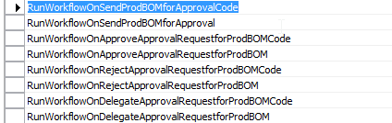

**RunWorkflowOnSendProdBOMforApprovalCode**

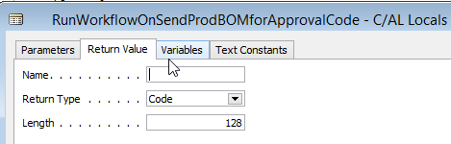

**RunWorkflowOnSendProdBOMforApproval**

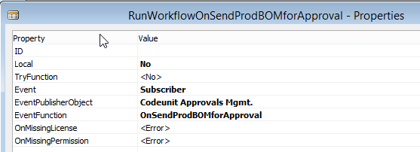

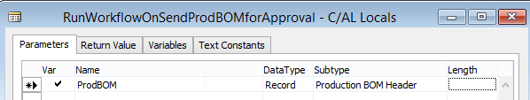

**RunWorkflowOnApproveApprovalRequestforProdBOMCode**

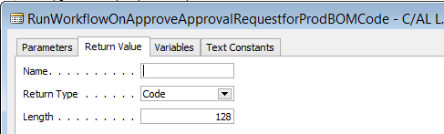

**RunWorkflowOnApproveApprovalRequestforProdBOM**

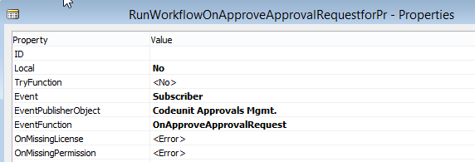

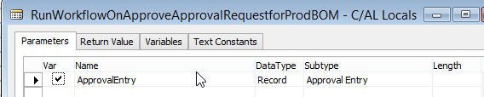

**RunWorkflowOnRejectApprovalRequestforProdBOMCode**

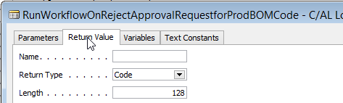

**RunWorkflowOnRejectApprovalRequestforProdBOM**

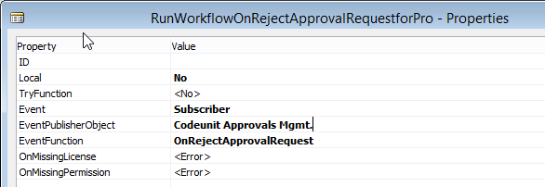

**RunWorkflowOnDelegateApprovalRequestforProdBOMCode**

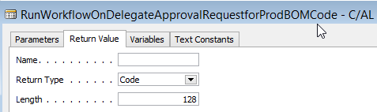

**RunWorkflowOnDelegateApprovalRequestforProdBOM**

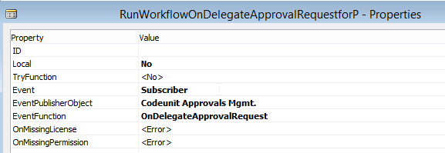

**TEXT CONSTANTS**

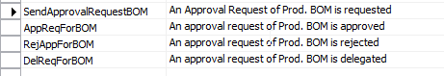

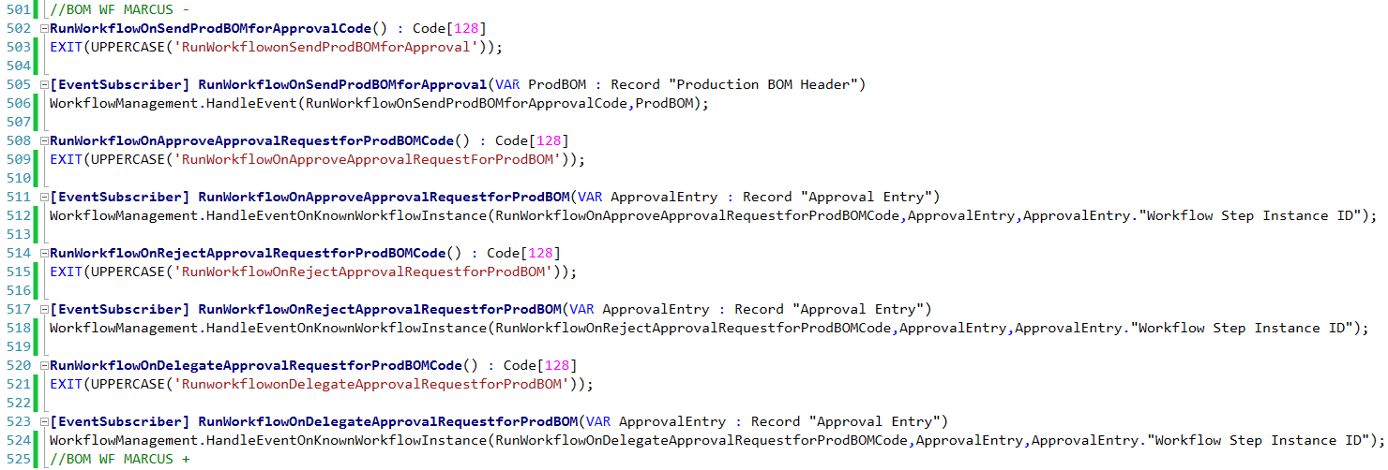

1. **CODEUNIT: 1521 -**

**Local - ReleaseDocument**

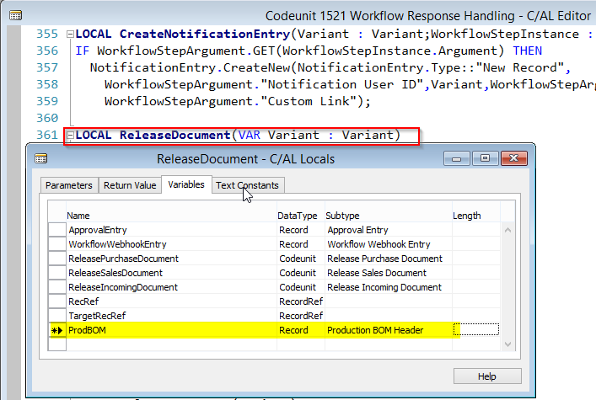

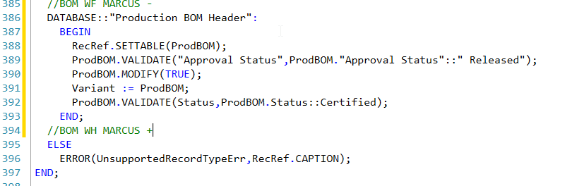

**Local - OpenDocument**

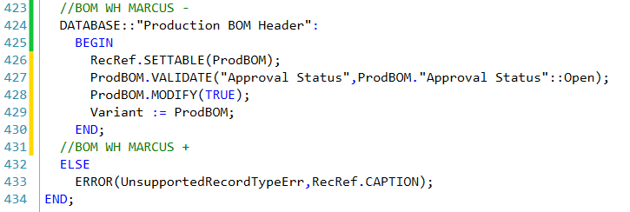

**CODEUNIT: 1535 – APPROVALS MGMT.**

**SetStatusPendingApproval**

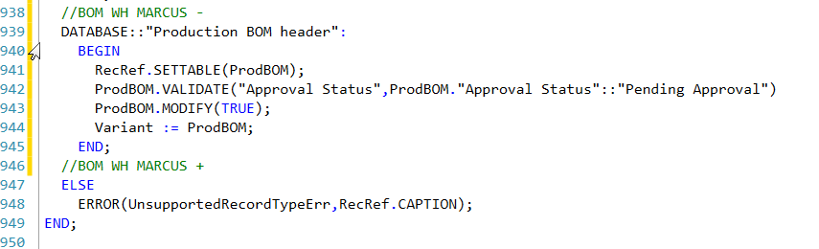

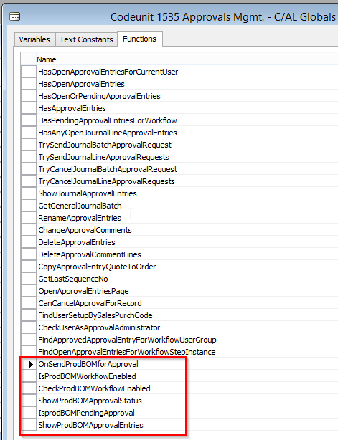

**OnSendProdBOMforApproval**

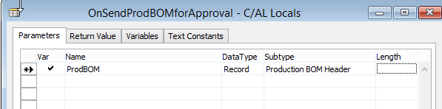

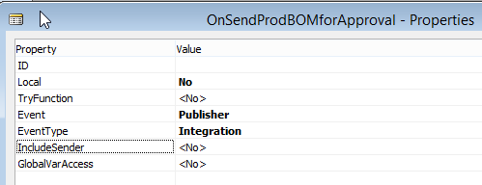

**IsProdBOMWorkflowEnabled**

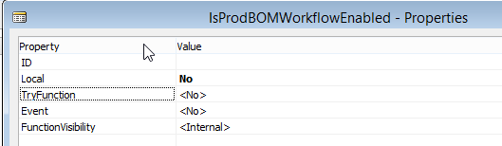

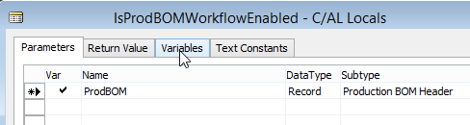

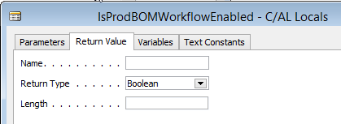

**CheckProdBOMWorkflowEnabled**

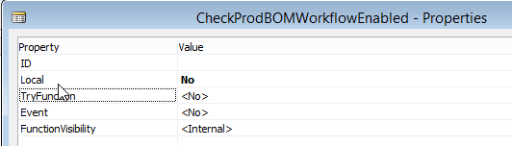

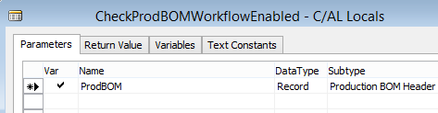

**ShowProdBOMApprovalStatus**

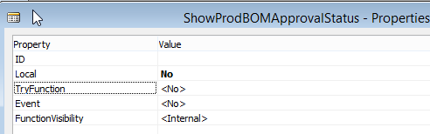

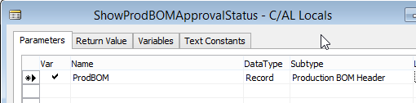

**IsProdBOMPendingApproval**

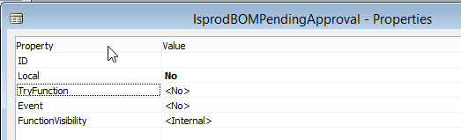

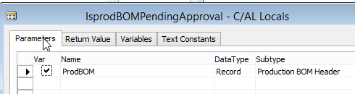

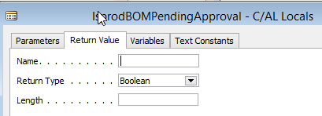

**ShowProdBOMApprovalEntries**

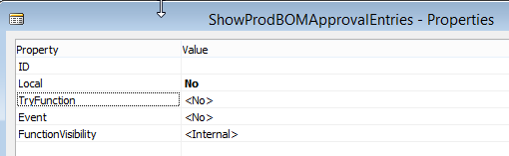

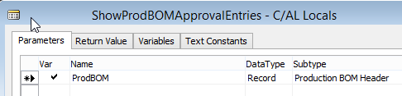

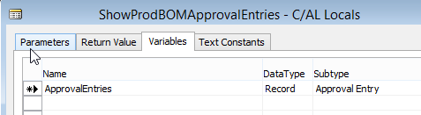

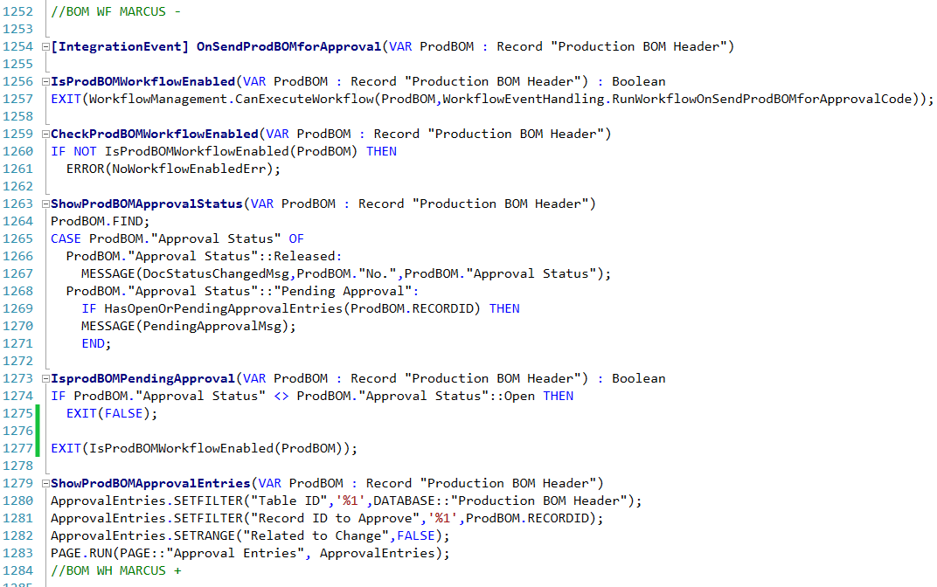

1. **SETUP:**

**Workflow – Table Relations**

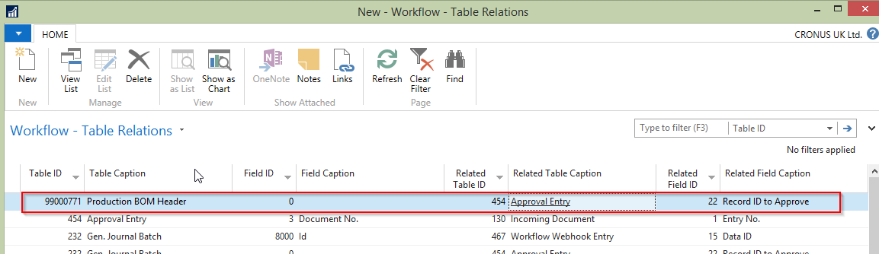

**Workflow**

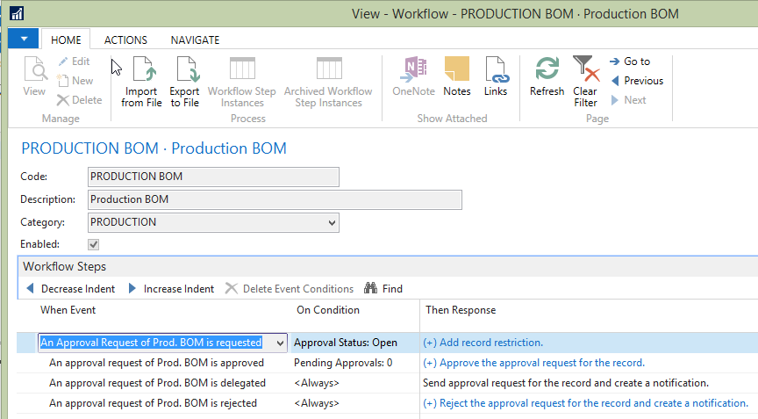

### 3.1.1 Modifications

The following new modifications have been completed and tested:

|  |  |  |  |
| --- | --- | --- | --- |
| Reference | Source | Type | Summary |
|  |  |  |  |

## 3.2 Object Changes

**Important Note**: If there is any discrepancy between the Original Object details and the corresponding Object Details in your database, please do not import them, but inform immediately with details.

### 3.2.1 Object Verification

|  |  |
| --- | --- |
| Source database object changes were developed in |  |
| Date development objects compared to live |  |

### 3.2.2 Existing

|  |  |  |  |  |  |  |
| --- | --- | --- | --- | --- | --- | --- |
| Object Type (table, form, etc.) | Object ID | Name | Modified | Version | Date | Time |
|  |  |  |  |  |  |  |

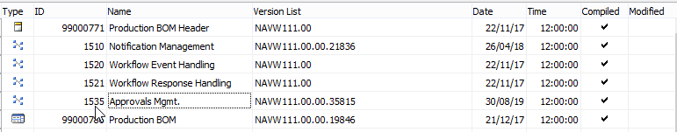

### 3.2.3 New

|  |  |  |  |  |  |  |
| --- | --- | --- | --- | --- | --- | --- |
| Object Type (table, form, etc.) | Object ID | Name | Modified | Version | Date | Time |
|  |  |  |  |  |  |  |

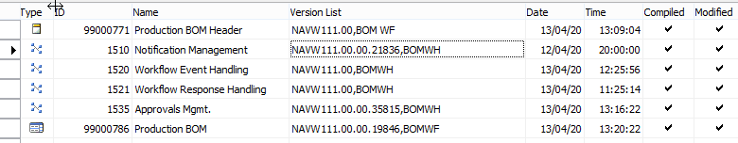

# 4 Summary of Data Fix

## 4.1 Preparation for Data

## 4.2 Steps to Perform Data Fix

## 4.3 File Changes

|  |  |  |
| --- | --- | --- |
| File name | New Version (where applicable) | File Usage (for information only, as a summary) |
|  |  |  |
|  |  |  |

|  |  |
| --- | --- |
| File name | File Type |
|  |  |
|  |  |

# 5 Deployment Steps

## 5.1 Pre-Requisites

**Important Note:**  If there is any discrepancy between the Original Object details and the corresponding Object Details in your database, please do not import them, but inform immediately with details.

### 5.1.1 Any Additional License Requirements

### 5.1.2 Dependencies

## 5.2 Distributed Files

NA

## 5.3 Backup Details / Rollback

Restore previous version of objects from back up file provided

## 5.4 Installation / File System Updates

NA

## 5.5 Restarts Required

Information on any services or application restarts required:

|  |  |  |  |
| --- | --- | --- | --- |
| Action | Service Name | Responsible | Remarks |
| Till Restart Required | Not required |  |  |
| DD Restart Required | Not required |  |  |
| NAS Restart Required | Required |  |  |
| Web Service Restart Required |  |  |  |

## 5.6 Data Set Up

## 5.7 Scheduler Set Up

### 5.7.1 Job Type (Batch of Replication Job)

### 5.7.2 Code Unit to be Run by Batch Job

### 5.7.3 Time Intervals and Frequency

## 5.8 Post Deployment Testing Steps

Please ensure your testing is proportionate to the level of risk.

### 5.8.1 To Test Code

### 5.8.2 To Test Data Fix

Not required

# 6 Quality Assurance

## 6.1 Testing Completed

NA

## 6.2 Code Review / Testing

|  |  |  |
| --- | --- | --- |
|  | Name | Date completed |
| Unit Test completed by |  |  |
| Code Review completed by |  |  |
| Testing completed by | Marcus Ambra |  |
| UAT testing completed successfully | Marcus Ambra |  |

# 7 Additional Information

## 7.1 3rd Party Products Released

|  |  |  |
| --- | --- | --- |
| Product | Build | Remarks |
|  |  |  |
|  |  |  |
|  |  |  |

## 7.2 Points to Note

None

# 8 Sign Off

|  |  |  |  |
| --- | --- | --- | --- |
| Action | Name | Signature | Remarks |
| Released By | Marcus Ambra | Marcus Ambra |  |
| Approved By |  |  |  |

All objects/changes moved in to your live environment by yourself or otherwise, are considered complete and approved. Any further changes required after this stage may be considered a new change request.

Please be aware that objects/changes not moved into your live environment within a reasonable amount of time, upon completed user acceptance testing, may cause conflict with other objects/changes.